# **Coffee drink quality**

Edgard Augusto de Toledo Picoli 1, Co-authors, Co-authors, Co-authors, etc, Junior Pastor Pérez Molina 2

1 Department of Plant Biology, Federal University of Viçosa, 36.570-000 Viçosa, Minas Gerais, Brazil. E-mail: [epicoli@ufv.br](mailto:epicoli@ufv.br)

2 Laboratory of Functional Ecology and Tropical Ecosystems (LEFET), School of Biological Sciences, National University of Costa Rica, Omar Dengo Campus, 86-3000 Heredia, Costa Rica. E-mail: [jpastorpm@gmail.com](mailto:jpastorpm@gmail.com)

Co-authors (…)

Co-authors (…)

*\*To whom correspondence should be addressed. E-mail:* [*epicoli@ufv.br*](mailto:epicoli@ufv.br)

*(Phone: +55 (31) 3899 1936)*

*Date of submission: 00/00/2019*

*X Tables; X Figures*

*Word count (start of the introduction to the end of the acknowledgement): 4000*

# **Abstract**

## Key words:

# **Abbreviations**

# **Introduction**

# **Materials and methods**

## ***Study area***

## ***Experimental design, plant material, and growth conditions***

## ***Data analysis***

*H*, *NL*, and *Fv/Fm* were evaluated by *Kruskal-Wallis* analysis (*KW*) for each week (1 to 4 weeks) for all light-deficiency treatment combinations (**Light**: *high* and *low*; and **Deficiency**: *(-)N* and *C*), and comparison *a posteriori* of *Fisher's Least Significant Difference* (*LSD*). Dry mass partitioning (*RMR*, *LMR*, *SMR*, *RLR*, and *TDM*) and concentration of leaf chlorophyll (*a*, *b*, *a/b*, and *total*) were evaluated by nested ANOVA for unbalanced samples with **Light** as main factor and nested deficiency within light factor (**Deficiency/Light**) and comparison *a posteriori* of *Fisher's LSD*. A ternary relationship between *SMR*, *LMR*, and *RMR* for all light-deficiency treatment combinations, were made. In addition, *Spearman* (*rs*) correlations between *RMR*, *LMR*, *SMR*, and *Fv/Fm* for all light-deficiency treatment combinations were performed, and fluorescence analysis between *LMR* and *RMR* was made. Multivariate associations among *Fv/Fm* and morphological traits were analyzed using a principal component analysis (*PCA*). The treatments that produced similar plant responses were clustered using a multivariate technique of grouping analysis according to the method of *Tocher*, which is based on average *Euclidean* *distances* (Rencher, 2003). *PCA* was performed using the package *factorextra* in *R* (Kassambara & Mundt, 2017). All of the statistical analyses were performed using *R* programming language, version 3.4.0 (Crawley, 2002; RCoreTeam, 2017) and with a significance level of α=0.05. Finally, in this research, the address of a repository is included for consultation of *R* script, database, and results of all the statistical analyses that were performed (see: <https://github.com/JPASTORPM/Project_Solanum_lycopersicum>).

# **Results**

# **Discussion**

# **Acknowledgments**

# **References**

# **Tables**

**Table 1.** Comparison of coffee drink quality traits and morpho-anatomic foliar features in four hillside positions (Noruega and Soalheira: fría and quente) in Minas Gerias, Brazil

|  |  |  |  |  |  |  |  |  |
| --- | --- | --- | --- | --- | --- | --- | --- | --- |
| **Traits** | **Varaible (Unit)** | **Abbr.** | **Hillside position** | | | | ***KW*** | ***P*** |
| **Noruega fria** | **Noruega quente** | **Soalheira fria** | **Soalheira quente** |
| *Coffee drink quality traits* | *Clean* | DQC | **5.87 ± 0.03 a** | **6.035 ± 0.043 b** | **6.035 ± 0.047 b** | **6.038 ± 0.034 b** | **17.6** | **\*\*** |
| *Sweetness* | DQS | **5.865 ± 0.041 a** | **5.975 ± 0.076 ab** | **6.074 ± 0.077 b** | **6.128 ± 0.05 b** | **15.9** | **\*\*** |
| *Acidez* | DQA | **6.007 ± 0.04 a** | **6.135 ± 0.075 ab** | **6.231 ± 0.067 b** | **6.217 ± 0.043 b** | **14.9** | **\*\*** |
| *Body* | DQB | **6.029 ± 0.031 a** | **6.138 ± 0.058 b** | **6.178 ± 0.056 b** | **6.212 ± 0.039 b** | **16** | **\*\*** |
| *Taste* | DQT | **5.901 ± 0.051 a** | **6.107 ± 0.084 b** | **6.1 ± 0.082 ab** | **6.157 ± 0.053 b** | **12.4** | **\*\*** |
| *Aftertaste* | DQR | **5.9 ± 0.048 a** | **6.009 ± 0.071 ab** | **6.078 ± 0.08 ab** | **6.162 ± 0.052 b** | **13.2** | **\*\*** |
| *Equilibrium* | DQE | **5.929 ± 0.031 a** | **6.116 ± 0.057 b** | **6.075 ± 0.055 b** | **6.066 ± 0.034 b** | **12.9** | **\*\*** |
| *Overall* | DQO | **5.929 ± 0.032 a** | **6.082 ± 0.056 b** | **6.135 ± 0.051 b** | **6.142 ± 0.034 b** | **23.4** | **\*\*\*** |
| *Quality total* | DQQ | **83.393 ± 0.262 a** | **84.56 ± 0.447 b** | **84.911 ± 0.473 b** | **85.117 ± 0.305 b** | **19.4** | **\*\*\*** |
| *Morpho-anatomic foliar features* | *Stomate density (n cm-2)* | SD | **157.961 ± 3.005 a** | **175.159 ± 6.241 b** | **158.897 ± 6.434 ab** | **174.169 ± 3.897 b** | **14.2** | **\*\*** |
| *Specific leaf área (mg cm-2)* | SLA | 6.065 ± 0.065 | 6.364 ± 0.127 | 6.331 ± 0.116 | 6.126 ± 0.094 | 6.2 | n.s. |
| *Avarage conductuvity (mS m-1)* | AC | 4096.94 ± 562.892 | 4929.986 ± 1031.933 | 4380.435 ± 905.814 | 5017.738 ± 1048.945 | 0.8 | n.s. |
| *Venation density (mm mm-2)* | VD | 7.435 ± 0.168 |  |  | 7.565 ± 0.157 | 381*U* | n.s. |
| *Transversal área (mm-2)* | PTA | 5.318 ± 0.172 |  |  | 4.958 ± 0.179 | 222 *U* | n.s. |
| *Vascular tissue área (mm-2)* | PVA | 0.665 ± 0.027 |  |  | 0.632 ± 0.037 | 237 *U* | n.s. |
| *Parenchyma área (mm-2)* | PPA | 4.653 ± 0.152 |  |  | 4.326 ± 0.159 | 219 *U* | n.s. |
| *Xylem área (mm-2)* | PXA | 0.358 ± 0.02 |  |  | 0.356 ± 0.033 | 217 *U* | n.s. |
| *Phloem área (mm-2)* | PFA | 0.307 ± 0.009 |  |  | 0.276 ± 0.009 | 258 *U* | n.s. |
| *Limbo (μm)* | ML | 0.273 ± 0.005 | 0.271 ± 0.006 | 0.286 ± 0.005 | 0.268 ± 0.006 | 6.4 | n.s. |
| *Upper epidermis (μm)* | MUE | **0.028 ± <0.001 a** | **0.025 ± <0.001 b** | **0.026 ± <0.001 b** | **0.029 ± 0.001 a** | **37.1** | **\*\*\*** |
| *Palisade parenchyma (μm)* | MPP | 0.062 ± 0.002 | 0.061 ± 0.002 | 0.062 ± 0.002 | 0.061 ± 0.002 | 0.3 | n.s. |
| *Lacuna parenchyma (μm)* | MLP | 0.173 ± 0.004 | 0.166 ± 0.004 | 0.18 ± 0.005 | 0.171 ± 0.005 | 5 | n.s. |
| *Lower epidermis (μm)* | MLE | 0.019 ± 0.001 | 0.018 ± <0.001 | 0.02 ± <0.001 | 0.019 ± <0.001 | 5.1 | n.s. |

Mean ± Standard Error. Equal letters indicate no statistically significant difference between hillside positions. *KW*: Kruskall-Wallis test (α= 0.05); *d.f.*= 4, 360; *n.s.*: not significant; **: *P*<0.01; ***: *P*<0.001; *P*: probability model. *U*: Mann–Whitney U test (α= 0.05).

# **Figures**

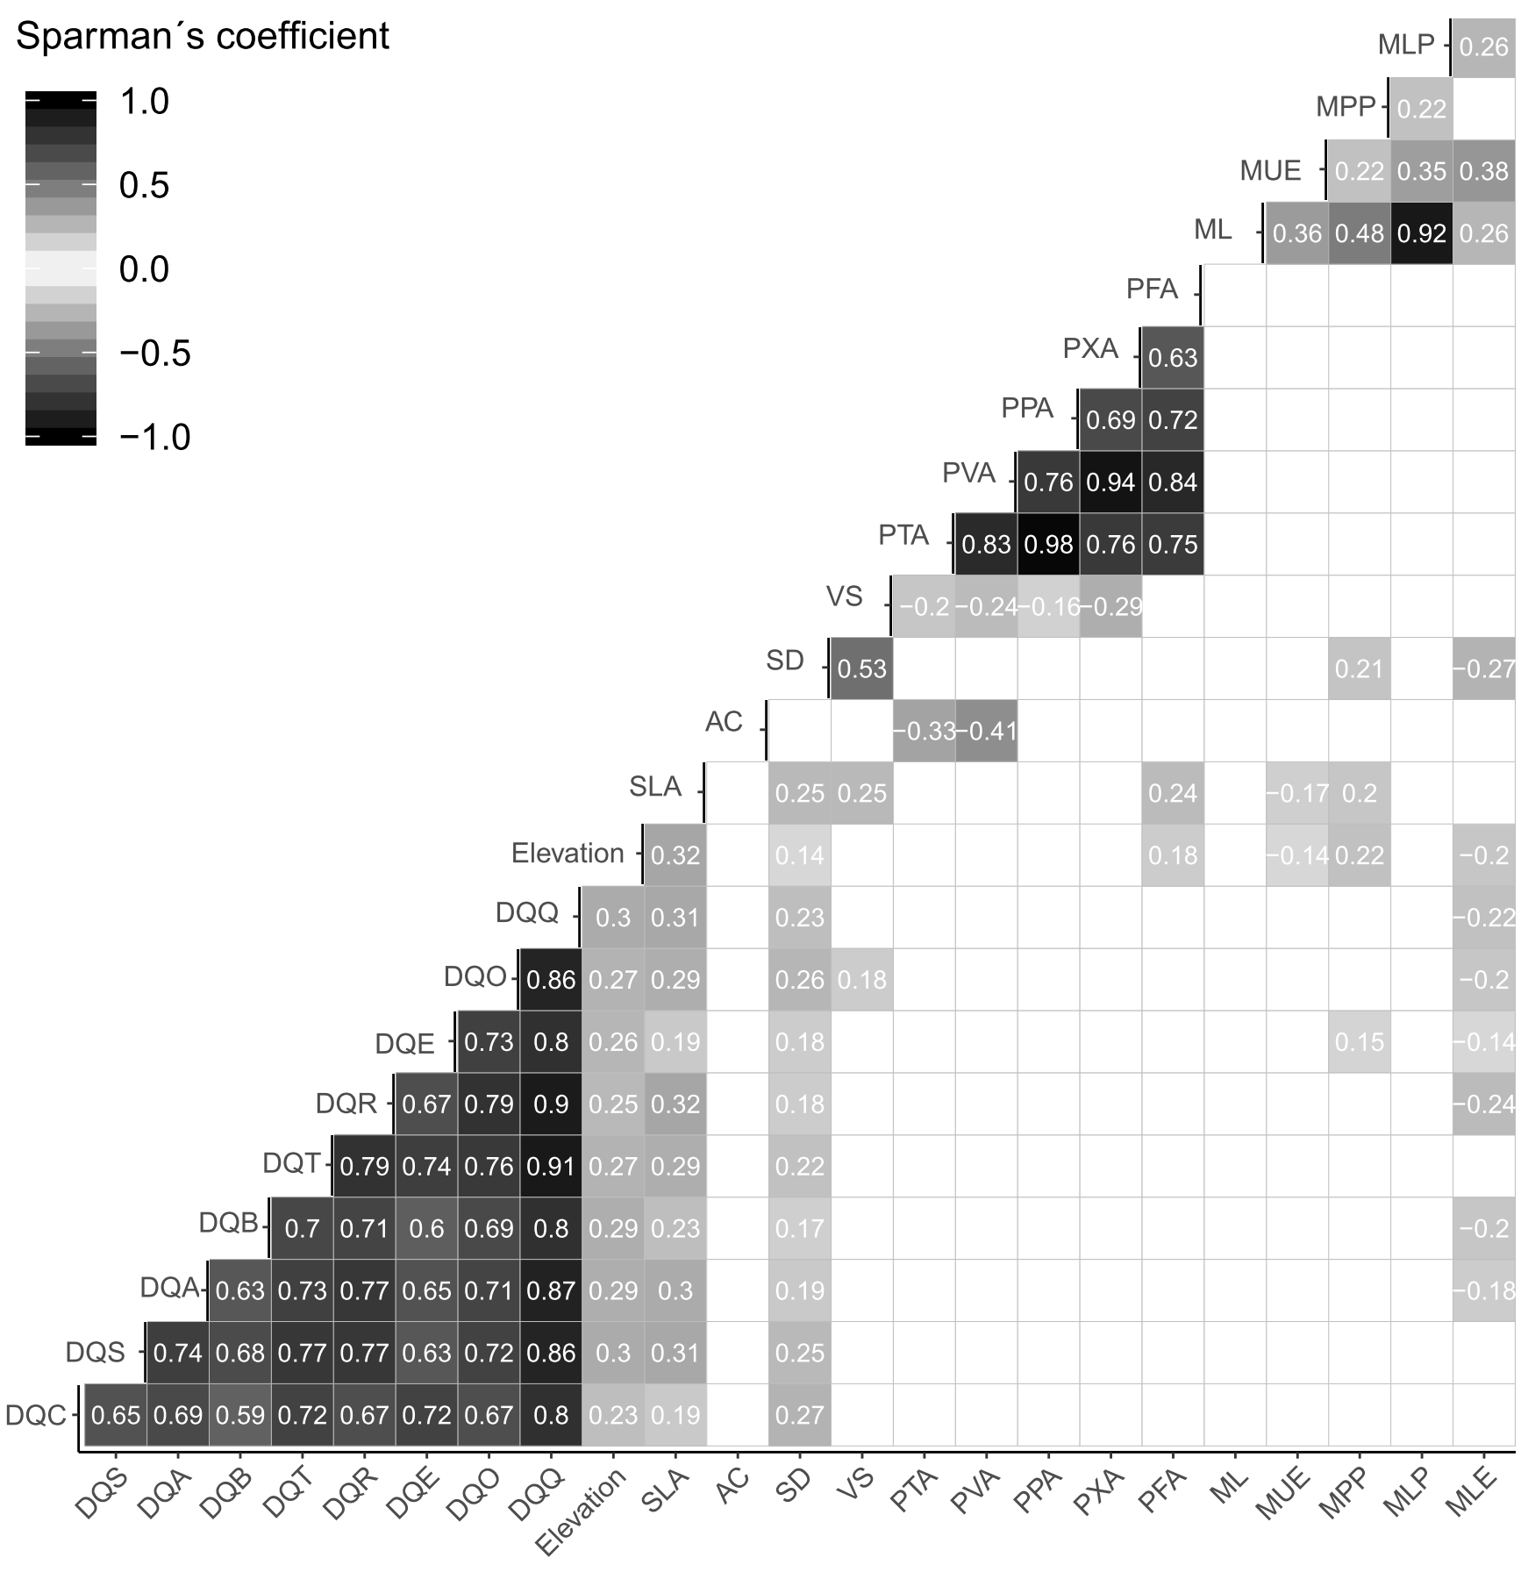

**Fig. 1.** Relationship between coffee drink quality traits and morpho-anatomic foliar features. Subplots above the diagonal represent the Spearman correlation coefficients (rs) between pairs of variables for all hillside positions (Noruega and Soalheira: fría and quente), P<0.05 for boxes with gray to black gradient, and no significant for white box (P>0.05).